Newsletter
- True North College Counseling Newsletter - October 2020

Upcoming Events

Virtual "Coffee Chat" with your College Counselor (for 10th grade parents only)
- Tuesday, November 10th | 10:00 am
- Register here
- Please check your email for Zoom link

Virtual "Coffee Chat" with your College Counselor (for 9th grade parents only)
- Tuesday, November 17th | 10:00 am
- Registration form and Zoom link will be emailed to parents the week of 11/9


NACAC Virtual College Fair
- Sunday, November 8th | 2 - 10 pm ET

The National Association for College Admission Counseling (NACAC) is the largest global organization that supports the professional development of college counseling and college admissions professionals. Each year, they host numerous in-person college fairs around the country in support of high school students’ college planning and research processes. Due to the ongoing pandemic, NACAC has shifted towards an online platform that allows students to continue engaging with higher education institutions through virtual college fairs. Check out what’s coming up soon!

- More than 600 colleges and universities will offer Zoom sessions and meetings. Students and parents everywhere can log in, drop in, and ask questions. These fairs offer an unparalleled opportunity for students and families to explore the vast college options that are available.

- Click here to see the list of colleges and universities scheduled to participate on November 8th and remember to sign up in order to access the virtual college fair space.

- Virtual College Fair Tips, Reminders & Resources
  - Tutorial video (navigating the virtual college fair) and quick start guide to make the most of your fair experience
  - Sign up at virtualcollegefairs.org and look around several days before the fair date. You can click the "Remind Me" button when you see a Zoom session that will be offered by a college that interests you.

College Planning Tools & Resources
- BigFuture by the College Board - online tool for comparison of colleges and universities, as well as exploration of majors and careers
- College Planning for 9th and 10th Graders (College Board)
- How to Make the Most of your Freshman Year (ACT Guide Book)
- How to Prepare for the Future During Your Sophomore Year (ACT Guide Book)
- College “Wishlist” Exercise - adapted from When to do What: A Step-by-Step Guide to the College Process (2017)

Standardized Testing
- College Board
- ACT, Inc.
- FairTest.org
- Comparison of Standardized Tests (PSAT/NMSQT, SAT, ACT, SAT Subject Tests)

Financial Aid & Scholarships
- Financial Aid Checklist (College Board)
- Florida Bright Futures Scholarship Program (Eligibility Requirements)
- Free Application for Federal Student Aid (FAFSA)
- CSS Profile
- Raise.Me
- MyIntuition

Florida Bright Futures Scholarship Program
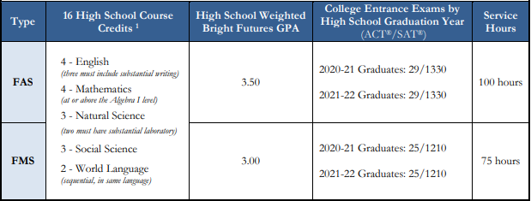

Financial Aid & Scholarship Opportunities
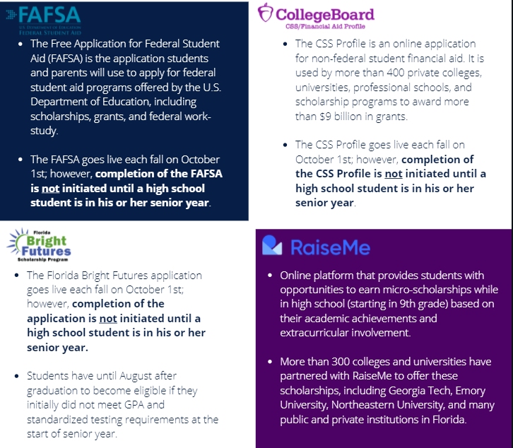
Virtual College Tour Resources
- You|Visit
- The Princeton Review Virtual Campus Tours
- eCampus Tours

College Admissions Blogs
- Tulane University Admission Blog -- Jeff Schiffman, Director of Admission
- Georgia Tech Admission Blog -- Rick Clark, Director of Undergraduate Admission
- University of Virginia Blog -- Jeannine Lalonde, Associate Dean of Admissions
- University of Southern California -- various Directors and Assistant Directors of Admission
  - Check out these relevant recent posts from USC!
    - Tips to Help Navigate Virtual College Fairs (10/16/2020)
    - Too Early to Apply? A Freshman and Sophomore High School Guide to Preparing Your College Application (10/15/2020) -- This post provides practical, honest, and realistic advice about steps to take now that will pay off in the future (and it isn’t as intimidating as you may think!)

Articles
- Resources coming soon!

Collegiate Athletics -- NCAA & NAIA
- Resources coming soon!

