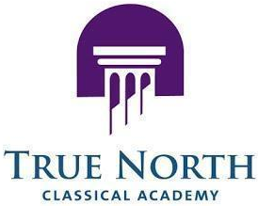
TRUE NORTH
truenorthcharter.org

Rescheduled
Meeting Notice

True North Classical Academy, Inc., is a not for profit agency operating a charter school, and therefore subject to Florida’s Government in the Sunshine Laws. As such, this notice is to announce a Board of Directors Meeting which is open to the public.

True North had previously announced a Governing Board meeting to be held on March 6, 2026 at 9:00 AM at 9393 Sunset Drive, Miami, FL 33173. However, the location for this meeting has been MOVED March 5, 2026 at the same time and location.

True North Classical Academy, Inc. Meeting of the Board of Directors

 | When: | December 5, 2026  09:00am
 | Where: | True North Classical Academy  - 9393 Sunset Drive  - Miami, FL 33173
 | Purpose: | Regular Board Meeting

If you should require any accommodations to be able to access or participate in the meeting, please contact Leo Gonzalez at lgonzalez1@truenorthcharter.org.

